Light Up Village of Oak Grove!

Best Lights and Decorations
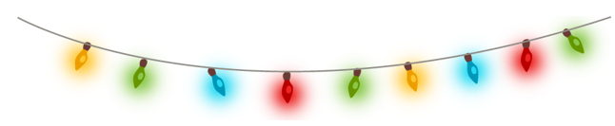
Saturday, December 24, 2022
There will be winners and prizes

.

